TABLE OF CONTENTS
- 1.0 PROJECT CHARTER & REQUIREMENTS SPECIFICATION
  - 1.1 Market Research & Competitive Analysis
  - 1.2 Vision & Scope
  - 1.3 Software Requirements Specification (SRS) - Use Cases
- 2.0 WORK BREAKDOWN STRUCTURE & PROJECT SCHEDULE
  - 2.1 Project Schedule & Gantt Chart Overview
  - 2.2 Phase 1: Initiation, Requirements & Architecture
  - 2.3 Phase 2: Core Development & Quality Assurance
  - 2.4 Phase 3: Final Deployment & System Handover
  - 2.5 Agile Product Backlog & Sprint Planning (Jira)
- 3.0 COMMUNICATION PLAN
  - 3.1 Team Meeting Cadence & Protocols
  - 3.2 Reporting Methods & Blocker Escalation Paths
  - 3.3 Primary Communication Tools & Platforms
- 4.0 RISK MANAGEMENT PLAN
  - 4.1 Risk Identification by Category (Technical, Schedule, Financial, People)
  - 4.2 Master Risk Register Table & Response Strategies
- 5.0 RESOURCES AND COST MANAGEMENT PLAN
- 5.1 Roles and Human Resources Plan (HR Table)
- 5.2 Bottom-Up Cost Estimation & Total Project Budget ($409,288)
- 5.3 High-Level Budget Summary & 4-Month Cashflows Schedule
- 5.4 Responsibility Assignment Matrix (RACI Matrix)
- 5.5 Key Budget Assumptions

1.0
1. Market Research & Competitive Analysis
For the existing software and landscape there are leaders in this market such as Park Mobile Spot Hero and even Ringo that have real time parking reservations and it also includes digital payments so these are the competitors
For these existing platform their strengths that they have established user bases and they also are integrated with the parking infrastructure and they have some reliable payment options
Some of the weaknesses of these platforms are that they have some navigation tools that you would have to switch apps to access they have very limited options for garage operators to have dynamic pricing and the real time occupancy updates are inaccurate and then there are admin analytics are not unified
So here are some opportunities for us to have some Differentiation We could integrate some turn by turn routing which this would be inside the application so users would not have to switch in between maps and the app We could also integrate AI which could predict the occupancy forecasting based on previous history and then also have this information to be updated in real time with data integration

2. Vision and Scope
So the Progret acquisition is WE ARE Software Corp It was awarded this project through a competitive enterprise bid and this was to deliver a unified end to end smart parking program
This company is a software development studio operating with unlimited developmental resources to engineer this Web and mobile platform that has high performance and outdoes its competitors
A project overview would be this smart parking platform which would connect drivers with parking garage operators and these drivers would be able to locate available spots in real time and how they would be able to reserve spaces in advance Also they wouldn’t have to switch apps they would be able to navigate to the garages within the app also they would be able to pay online through the app digitally they also would have access to live occupancy tracking specifically the garage operators and they would also have financial reporting city ordinance compliance tools to help them run the app and also dynamic price controls which would allow them to change on demand

3. Software Requirements Specification (SRS) - Use Cases Draft
1. This could be a driver searches for an available garage spaces based on the proximity and they could look for this through an interactive map
2. A user could complete their payment through maybe a 3rd party processor like Apple Pay or input their credit card information
3. A driver should be able to reserve a spot so they could choose a time duration and advance a parking reservation which would update in the app
4. They should also be able to report a space issue so notify garage management if an assigned spot is occupied or maybe unavailable upon arriving for other reasons
5. They should have dynamic pricing rules which could adjust peak versus non peak rates and then manually or automated shift pricing during these high demands or event schedules
6. System administrators should be able to manage user access grant operator permissions and also suspend accounts which are violating the terms of service
7. There should also be maybe advanced search filtering which filters locations by hourly rates covered versus the uncovered spots if there’s maybe electric charging or the level of accessibility
8. there should also be user registration which helps create an account and put vehicle license make model etc and also somewhere to safely store payment details
9. There should also be a way to enter the gate especially if booked advanced parking maybe scanning a QR code or triggering the automatic license recognition
10. There should also be a time extension where you can receive expiration alerts and also remotely add time to an active reservation and we also need to see how this would work with . advance registration to make sure things don’t overlap
11 There should be a space where there is frequently used garages so you can book it in one tap
12. There should also be an operator dashboard where they can log into an administrative portal with role based access control
13. Management should also receive automated alerts for vehicles exceeding their reserve time so this can trigger enforcement or to apply a fee to their account
14 There should also be a way to broadcast system alert which notifies performance maintenance traffic disruptions or maybe some weather emergencies
15. Also a way to sync location with the garage’s entrance with maybe Google Maps or Apple Maps which would be accessible within the app

2.0
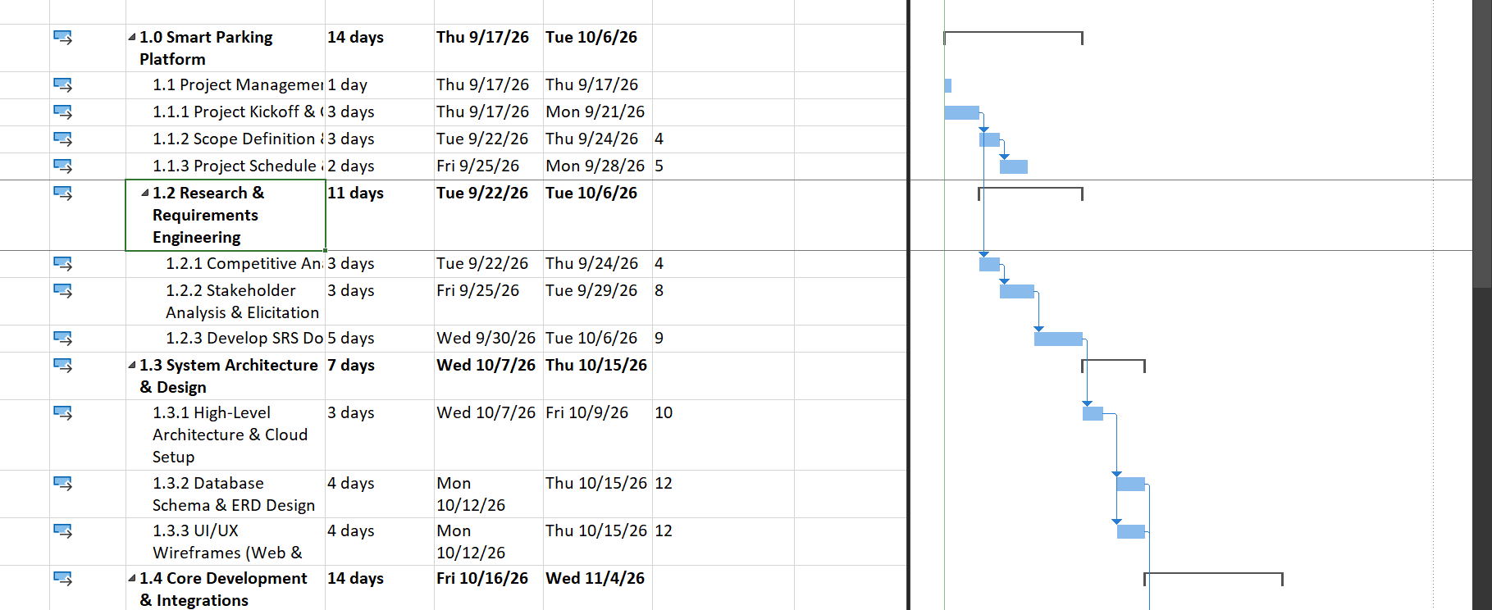

Smart Parking Platform WBS task hierarchy showing initiatin, requirements engineering, and architecture design phases (Sept–Oct 2026)
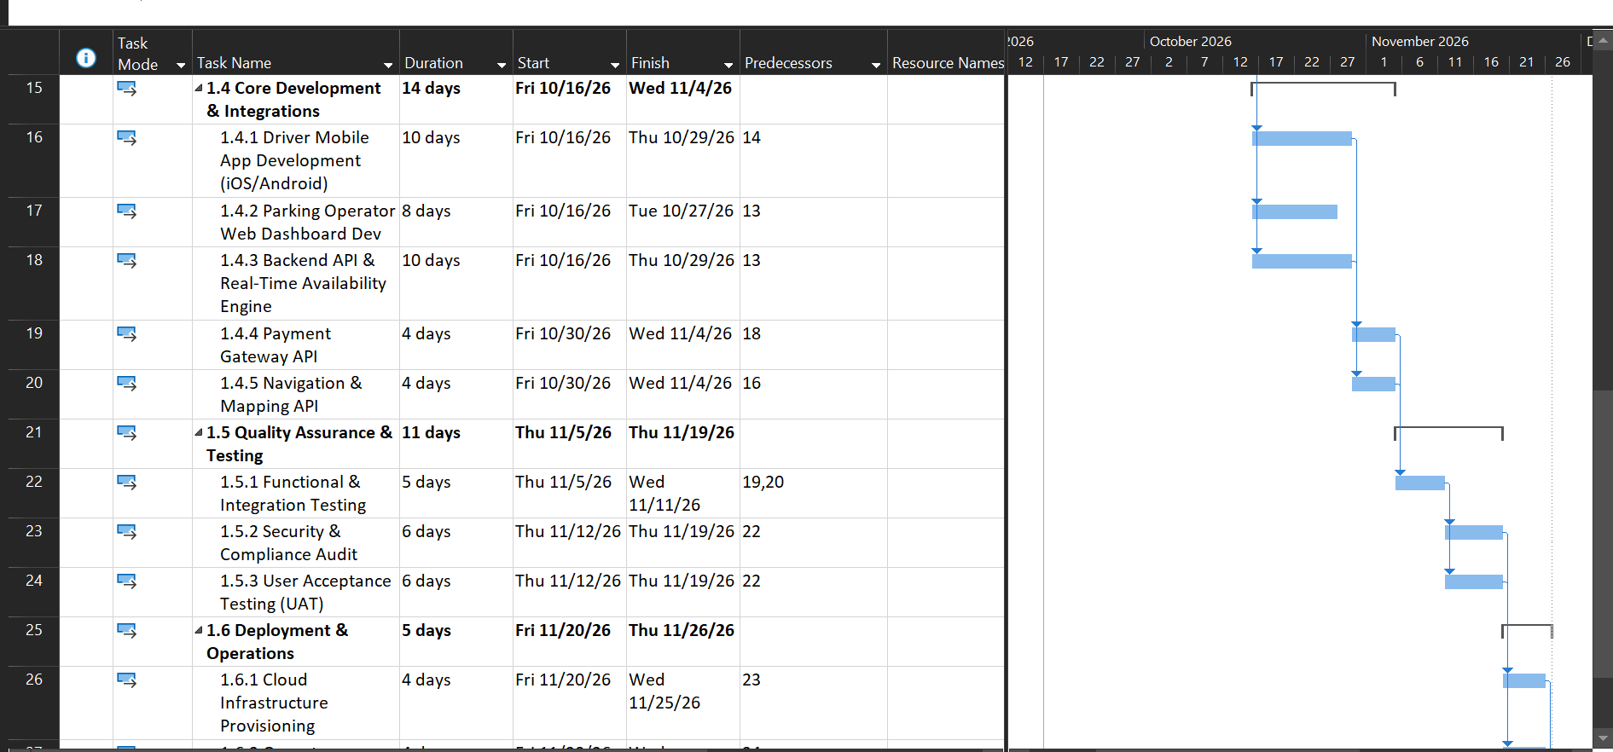
Development, quality assurance, and deployment phases showimg the predecessor logic and module integration links (Oct–Nov 2026)
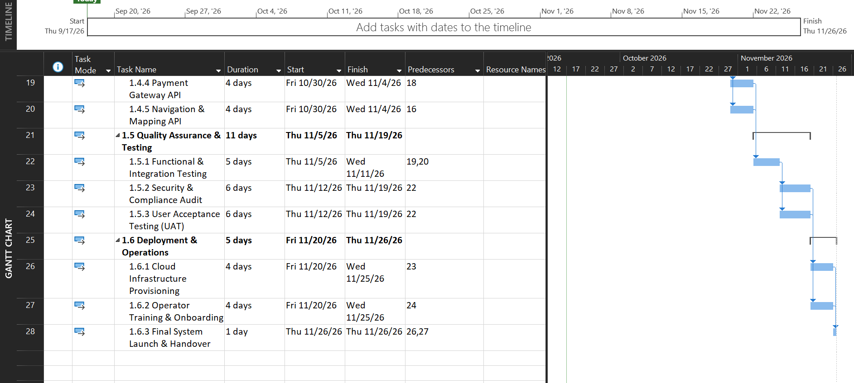

Final system launch sequence showing UAT, infrastructure provisining, and project sign off completng in late November 2026

Hw 3
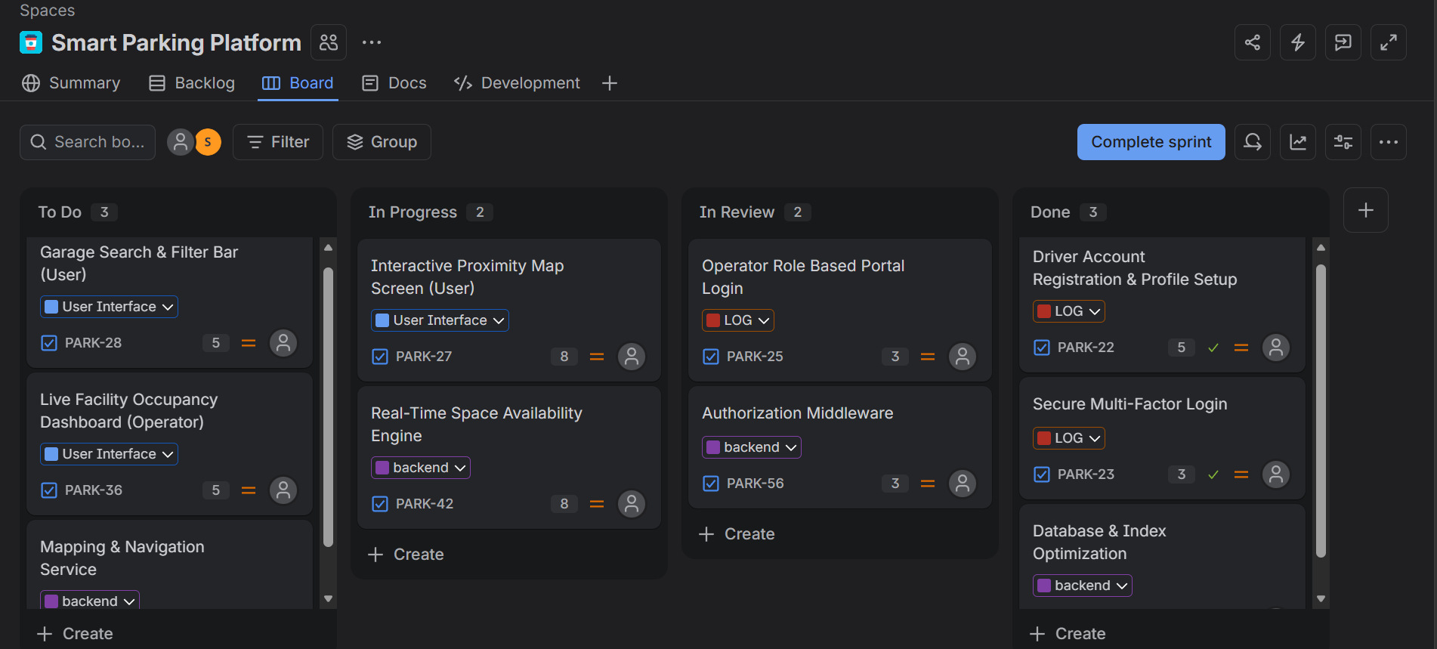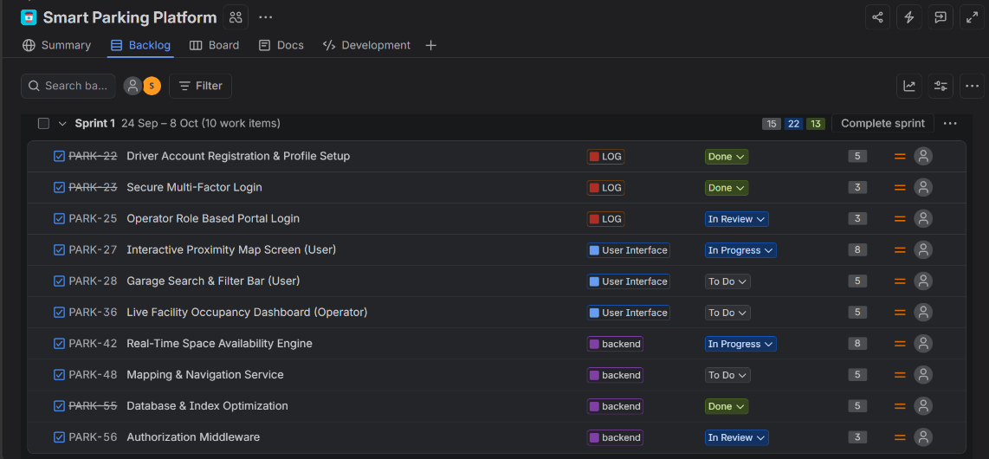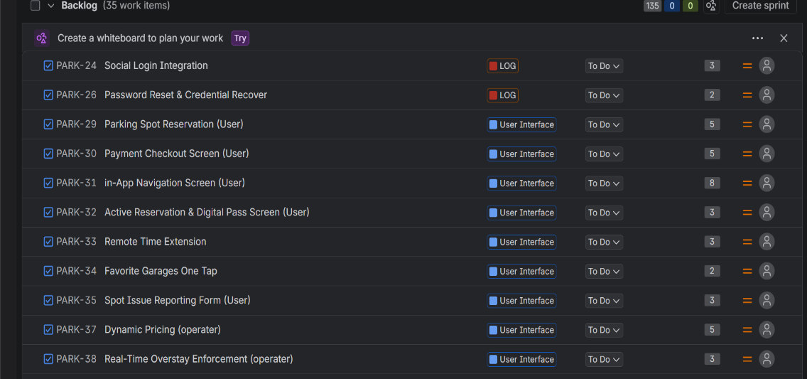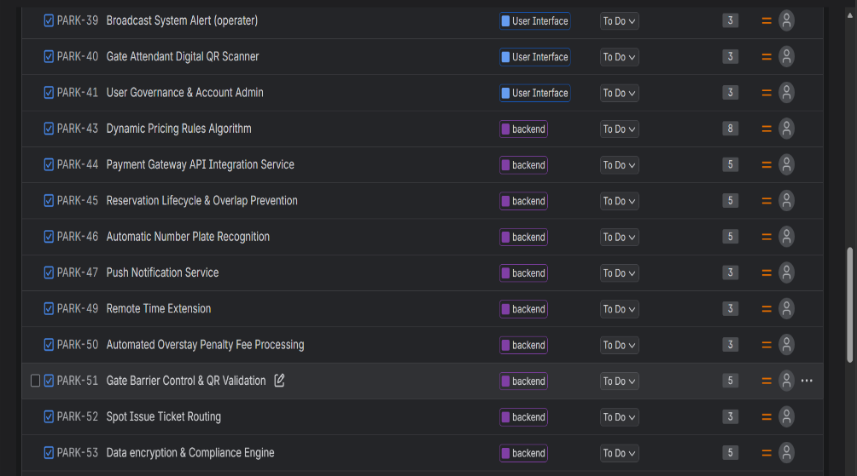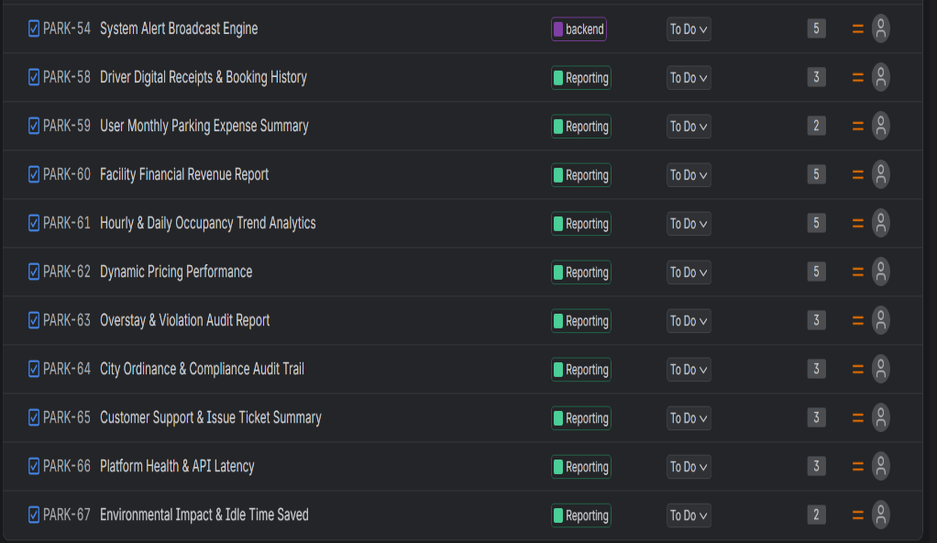

To organize the developmental tasks and follow agile project management standards, I set up the product backlog inside Jira for our team at WE ARE Software Corp. The total backlog consists of 45 items categorized across four core epics: Login & Auth, UI, Backend Processes, and Reporting. For Sprint 1, I pulled 10 high-priority foundational tasks into our active sprint board to lay down the groundwork for user login, database schemas, and map interfaces. Below are the screenshots showing the complete product backlog structure and the active Sprint 1 workflow board with tasks moving across To Do, In Progress, In Review, and Done.

HW 4
Part 1: Risk Identification by Category
1. Technical Risks
- TR-01 (Map & Navigation Lag): Third-party map APIs (like Google Maps) taking too long to load or failing during navigation inside the app.
- TR-02 (Parking Sensor Sync Failure): Garage gate sensors losing internet connection, causing the app to display incorrect available spot counts.
- TR-03 (Payment Processing Outages): Third-party payment gateways (like Stripe) going down during peak parking hours, preventing users from paying.
- TR-04 (License Plate Reader Glitches): Garage entrance cameras misreading license plates in bad weather or dark lighting, delaying entry.
2. Schedule Risks
- SR-01 (App Store Approval Delays): Taking longer than expected to get developer account approvals and app listings approved on Apple & Google app stores.
- SR-02 (Database Optimization Bottleneck): Backend database setup taking longer to finish, which pushes back the front-end app development schedule.
- SR-03 (Scope Creep): Adding extra unplanned features (like custom city reports or extra dashboard tools) mid-sprint.
- SR-04 (Testing & Audit Sign-Off Delays): Security reviews and user testing taking longer than planned, putting the end-of-semester deadline at risk.
3. Financial Risks
- FR-01 (Cloud Hosting Cost Spikes): Server hosting costs on AWS going over budget due to unexpected high user traffic during major city events.
- FR-02 (Refund & Dispute Fees): Extra processing fees caused by user refund requests or disputed parking charges.
- FR-03 (City Compliance Fines): Unexpected fines or penalties if the app fails to follow local city parking tax rules or zoning ordinances.
- FR-04 (API Subscription Escalations): Third-party mapping and messaging API costs increasing as more drivers use the app.
4. People Risks
- PR-01 (Key Developer Leaving): A core backend or mobile developer leaving the team mid-project, slowing down sprint progress.
- PR-02 (Team Communication Gaps): Misunderstandings between separate sub-teams (like Mobile vs. Backend) regarding how APIs connect.
- PR-03 (Garage Staff Resistance): Garage attendants struggling or resisting to learn the new operator dashboard software.
- PR-04 (Unintentional Security Slip-ups): Team members accidentally pasting private code or keys into unapproved public tools, violating course and project security rules.

Part 2: Risk Register
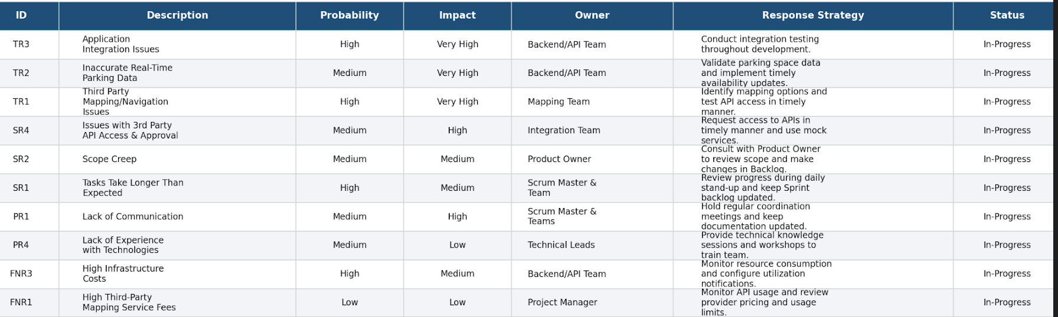

Part 3: Communication Plan
1. Meeting Cadence per Team
- Daily Standup (15 mins): Held every morning within each sub-team (Mobile, Web, Backend, Mapping, QA) to quickly share what was done yesterday, what's planned today, and any immediate blockers.
- Weekly Cross-Functional Sync (45 mins): Team leads and project managers meet weekly to review shared API work, check schedule progress, and update the Risk Register.
- Bi-Weekly Sprint Review & Planning (60 mins): The whole team gets together every two weeks to demo finished features, review feedback, and pick tasks for the next sprint.
- Monthly Stakeholder Meeting (30 mins): Project managers present high-level milestone progress, budget status, and key project health metrics to executive leaders and garage operator partners.
2. Reporting Methods
- Jira Dashboards & Progress Boards: Used to track user story status, sprint task progress, and sprint burndown charts in real time.
- Team Messaging (Slack / MS Teams): Organized channels (like #dev-backend, #dev-mobile, #general-updates) for day-to-day questions and quick team updates.
- Weekly PDF Status Reports: Summaries sent out every Friday by the project manager highlighting schedule status, open risks, and upcoming deliverables.
- Emergency Escalation Process: Major proect blockers (like critical payment or database bugs) are escalated directly to the Lead Developer and PM via instant alert so they can be fixed right away.

5.0 RESOURCES AND COST MANAGEMENT PLAN

5.1 Roles and Resources
The Smart Parking Platform project uses a Scrum-based team setup. Our team consists of 11 core roles across project management, software development, testing, and security.

1. Role Descriptions
Role / Team | Primary Responsibilities
Project Manager | Tracks the overall project schedule, manages budget, monitors risks, and sends status reports to stakeholders.
Product Owner | Manages the product backlog, prioritizes user stories, and represents user needs.
Scrum Master | Leads daily standups, removes technical blockers for the team, and keeps sprints on track.
Technical Lead / Architect | Designs system architecture, selects tech stacks, and oversees API integrations between sub-teams.
Backend / API Team | Builds server logic, database schemas, user authentication, and real-time parking spot availability services.
Mobile Application Team | Develops iOS and Android mobile app interfaces and user navigation screens.
Web Application Team | Develops the garage operator web portal and administrative dashboards.
Mapping & Location Team | Integrates turn-by-turn navigation APIs and GPS location tracking.
Payment Integration Team | Connects secure payment gateways (Stripe and PayPal) for driver reservations and billing.
SecOps Specialist | Handles user data encryption, access controls, and security compliance.
QA and Testing Team | Conducts unit testing, integration testing, performance checks, and user acceptance testing.

2. Human Resources Plan (HR Table)
Full-time commitment (100% FTE) equals 160 working hours per month.
Role | Assigned Name | Skill Level | FTE % | Hours / Mo | Hourly Rate | Monthly Cost
Project Manager | Mitch Carter | Senior | 50% | 80 | $65 | $5,200
Product Owner | Sarah Davis | Senior | 40% | 64 | $60 | $3,840
Scrum Master | Greg Brooks | Senior | 50% | 80 | $55 | $4,400
Technical Lead | Alex Kipp | Senior | 75% | 120 | $75 | $9,000
Backend Lead | Ryan Patel | Senior | 100% | 160 | $65 | $10,400
Mobile App Lead | Noah Goff | Intermediate | 100% | 160 | $55 | $8,800
Web App Lead | Ava Davis | Intermediate | 100% | 160 | $55 | $8,800
Mapping Lead | Jordan Chang | Senior | 100% | 160 | $63 | $10,080
Payment Lead | Ethan Myers | Senior | 100% | 160 | $65 | $10,400
SecOps Specialist | Jared Poe | Senior | 50% | 80 | $70 | $5,600
QA Lead | Sophia Ramirez | Senior | 100% | 160 | $50 | $8,000
TOTALS | 11 Members | -- | -- | 1,384 Hours | -- | $84,520

5.2 Resource and Cost Plan (Bottom-Up Estimation)
Costs are calculated over a fixed 4-month timeline using a bottom-up estimation method for labor and non-labor expenses, plus a 10% contingency reserve.

1. Labor Costs
• Monthly Labor Expense: $84,520
• 4-Month Total Labor Cost: $84,520 × 4 = $338,080

2. Non-Labor Costs
Expense Item | Monthly Cost | 4-Month Total
Cloud Hosting & DB (AWS) | $2,000 | $8,000
Mapping APIs (Google Maps) | $1,500 | $6,000
Payment Gateway Sandbox (Stripe) | $1,000 | $4,000
Dev Tools & Licenses (Jira, GitHub) | $1,500 | $6,000
Security Audits & Compliance | $1,000 | $4,000
Legal & Municipal Review | $1,000 | $4,000
Team Training Materials | $500 | $2,000
TOTAL NON-LABOR COST | $8,500 | $34,000

3. Total Budget Calculation
• Base Project Cost: $338,080 (Labor) + $34,000 (Non-Labor) = $372,080
• Contingency Reserve (10%): $372,080 × 0.10 = $37,208
• TOTAL ESTIMATED PROJECT BUDGET: $409,288

5.3 High-Level Budget Summary Table
Category | Cost Type | Rate / Units | Duration | Total Cost
Project Team Labor | Labor | 1,384 hrs/month at $61.07/hr avg | 4 Months | $338,080
Cloud Infrastructure | Hosting | $2,000 per month | 4 Months | $8,000
Mapping & Location Services | Third-Party APIs | $1,500 per month | 4 Months | $6,000
Payment Gateway Services | API Sandbox | $1,000 per month | 4 Months | $4,000
Software Tool Licenses | Software | $1,500 per month | 4 Months | $6,000
Security & Legal Compliance | Services | $2,000 per month | 4 Months | $8,000
Training & Onboarding | Materials | $500 per month | 4 Months | $2,000
Contingency Reserve (10%) | Reserve Pool | 10% of base project cost | N/A | $37,208
TOTAL BUDGET | -- | -- | -- | $409,288

5.4 Monthly Cashflows Schedule
Expenditures are distributed across the 4 execution months. Spending increases in Months 2 and 3 during active feature building and integration testing.
Month | Labor | Non-Labor | Base Cost | Contingency (10%) | Total Monthly Cashflow
Month 1: Setup & Architecture | $70,000 | $6,500 | $76,500 | $7,650 | $84,150
Month 2: Core Development | $85,000 | $8,500 | $93,500 | $9,350 | $102,850
Month 3: Integration & Testing | $95,000 | $10,500 | $105,500 | $10,550 | $116,050
Month 4: Security & Launch | $88,080 | $8,500 | $96,580 | $9,658 | $106,238
TOTALS | $338,080 | $34,000 | $372,080 | $37,208 | $409,288

5.5 RACI Matrix
• R = Responsible: The role that does the work.
• A = Accountable: The role with final approval power (only 1 A per task).
• C = Consulted: Roles providing input and expertise.
• I = Informed: Roles updated on task progress.
Task / Deliverable | PM | PO | Scrum Master | Tech Lead | Dev Teams | QA | SecOps | Stakeholders
Requirements & Scope Definition | A | R | C | C | C | C | C | C
Product Backlog Prioritization | C | A/R | C | C | C | I | C | C
System Architecture & ERD | I | C | C | A/R | C | C | C | I
Mobile & Web App Development | I | C | C | A | R | C | I | I
API Integration & Database Setup | I | C | C | A | R | C | C | I
SecOps & PCI Compliance | C | C | C | A | C | C | R | C
System Testing & QA | I | C | C | C | R | A/R | R | I
Final System Demo & Launch | R | C | C | C | I | C | C | A/R

5.6 Key Budget Assumptions
• Timeline: Project runs on a strict 4-month development schedule.
• Work Hours: Full-time roles are budgeted at 160 hours per month.
• Rates: Hourly billing rates match standard market rates for software development roles.
• Contingency: The 10% contingency reserve is managed as a shared pool for unexpected scope changes or emergency technical needs.

